

**Storage Management GUI (Poseidonos-GUI)**

Samsung Poseidon

User Manual

**Contents**

**1** **Introduction** 4

**2** **Poseidonos-GUI: Getting started** 5

**2.1** **Accessing the Poseidonos-GUI** 6

**2.2** **Poseidonos-GUI Dashboard** 8

**2.3** **Poseidonos-GUI Storage Management** 9

***2.3.1*** ***Array Management*** 10

***2.3.2*** ***Volume Management*** 17

**2.4** **Poseidonos-GUI Telemetry** 29

***2.4.1*** ***Telemetry Configure*** 29

***2.4.2*** ***Grafana*** 30

**2.5** **Poseidonos-GUI User Management** 31

2.6 **Poseidonos-GUI Storage Management Operations and Configurations** 33

***2.6.1*** ***Poseidonos Operations*** 33

***2.6.2*** ***Devices*** 34

***2.6.3*** ***Subsystems*** 35

**3** **How to install Poseidonos-GUI** 40

**4** **How to Uninstall Poseidonos-GUI** 44

**Overview**

This document describes the POS Storage Management GUI (also called as Poseidonos-GUI). Poseidonos-GUI enables a user to perform the following functions:

* Dashboard
* Array management
* Volume management
* System resource availability
* User management
* System status

This document covers the following topics:

* Introduction
* Getting started with Poseidonos-GUI
* Array and volume configuration
* User management
* POS Operations and Configurations

1. **Introduction**

POS Storage Management GUI aka Poseidonos-GUI enables an easy way to administer POS storage system.

The major objectives of Poseidonos-GUI are:

* **Availability**: Poseidonos-GUI is available from various devices, platforms and systems.
* **Speed**: Poseidonos-GUI provides data with highest performance so that users have access to important data at right times.
* **Simplicity**: A simple and intuitive design to help productivity and overall cost.
* **Commonality**: Commonly used graphics, widgets and terminology enable easy integration with existing systems and onboarding the users quickly.

With these deliverables in mind, a System Administrator can use the Poseidonos-GUI to configure and prepare the storage system for the user workloads quickly after completing the setup. Then the System Administrator can manage the system with minimal knowledge.

Array and volume storage configuration and management is streamlined in Poseidonos-GUI. User management is simplified.

1. **Poseidonos-GUI: Getting started**

This section describes how to accomplish the following tasks:

* Accessing the Poseidonos-GUI
* Managing and monitoring the POS system (e.g. array or volume management)
* User management
  1. **Accessing the Poseidonos-GUI**

The Poseidonos-GUI can be accessed using Firefox Mozilla and Google Chrome browser.

The Poseidonos-GUI supports the use of a single point of authentication function for the GUI through a centralized data in a lightweight database.

Poseidonos-GUI is accessible from the browser as shown in Figure1



1. *Poseidonos-GUI URL*

On the first page for Poseidonos-GUI, user needs to log on as an administrator.

1. Poseidonos-GUI URL: http://<Poseidonos-GUI_ip>**Error! Hyperlink reference not valid.**

*Note: Poseidonos-GUI URL may come pre-installed and typically the IP address of the server that the Poseidonos-GUI software is installed on*

1. On a new system, users can use the following default credentials:
   * User = admin
   * Password = admin

After initial login, user can add additional users using admin privileges

*Note: Poseidonos-GUI supports "admin" role only at this time.*

1. Users can configure the Telemetry API endpoint for viewing the metrics in PoseidonOS-GUI by clicking on the “CONFIGURE” button

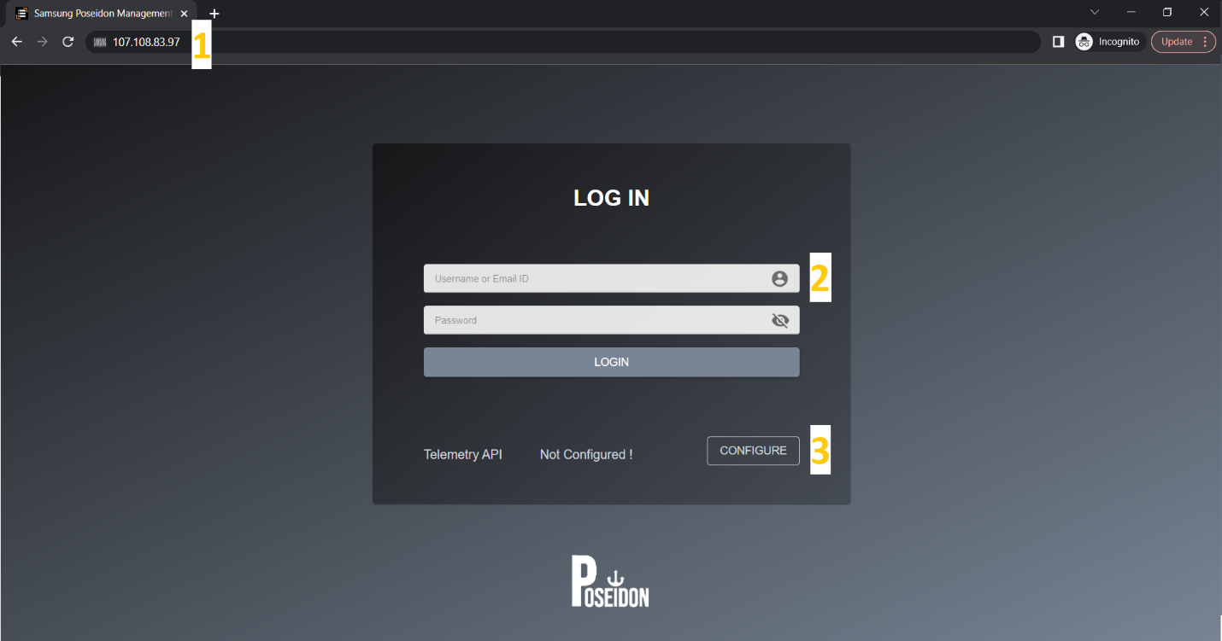

1. *Poseidonos-GUI login page*
2. In the configuration screen, users can enter the IP and Port of Telemetry API and save it, or skip the configuration

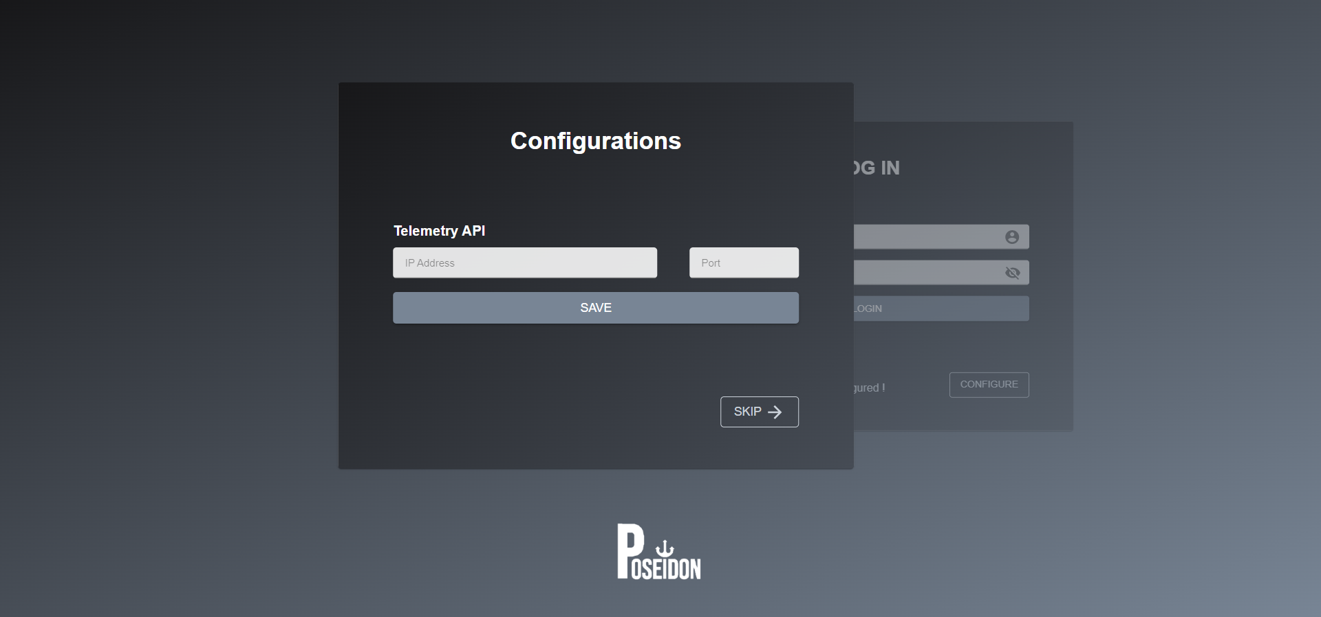

1. Telemetry API Configuration
2. The configured IP shows up in the Login screen

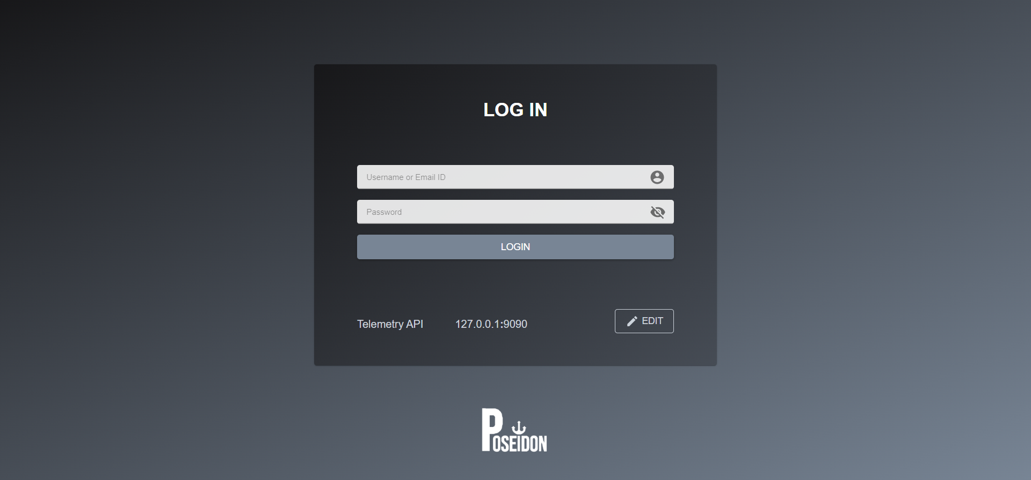

1. Login Screen Telemetry API configured
   1. **Poseidonos-GUI Dashboard**

Dashboard provides user an overview of the Poseidon Storage. It has three sections,

* Performance overview
* Storage Details
* Storage Summary

In addition, it also has links to few admin tasks such as storage management functions, etc. It also shows the current working status of the storage management system and the last time the status is updated.

1. **Performance Overview** shows the basic performance details such as Latency, Bandwidth and Throughput of the storage management box.
2. **Status Label** shows whether the storage management is available or not.
3. **IP Info** shows the IP address of Poseidon and Telemetry
4. **Storage Details** shows the space utilization in the storage management box.
   * **Array Summary** provides the array level information
   * **Volume Summary** provides the volume level information
5. **Hardware Health** shows the **temperatures & spares** health in 3 types Nominal, Warning & Critical.

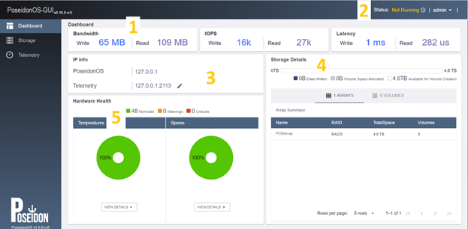

1. *Poseidonos-GUI dashboard page*
   1. **Poseidonos-GUI Storage Management**

The Storage Management page allows user to create an array and volumes, view existing array and volumes and manage existing arrays and volumes.

1. User can create one or more arrays based on the types of disks selected in the slots .i.e. Storage, Spare and Write Buffer Disks.
2. User can create a single or multiple volumes at a time by specifying the volume name, volume size, volume count and description.
3. User can view the volume information including volume name, volume size, used size, IP, description and status in a tabular format.
4. User can view the existing space for volume creation process.

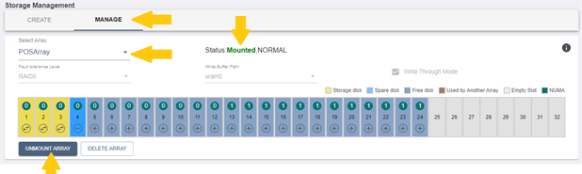

1. Poseidonos-GUI storage management page
   * 1. ***Array Management***

Array management option allows user to create and manage one or more arrays.

*Create Array*

Follow the steps below to create sample array creation process:

1. **Array Name -** Select a name for the array (e.g. name = array_1; Max length = 63 characters)
2. **Fault Tolerance Level** – Select from the dropdown
3. **Disk Type** - Select storage disks from the dropdown list. The 2 options for disk type are (Minimum Storage Disks = 3; Maximum Storage Disks = 32; Minimum Spare Disks = 0; Maximum Spare Disks = 29)
   * Storage Disk
   * Spare Disk
4. **Write Buffer Path** – Select from the dropdown list.
5. **Write Through Mode** – Select this option to mount the array in Write through Mode
6. User can view the available disks.

*The max number of allowable disks is 32.*

1. User can view the color codes for various types of disk supported by Poseidonos-GUI. User can view additional details - name, size- by hovering over disk number
2. User can view the **NUMA** value of the disks.
3. Click **Create Array** button

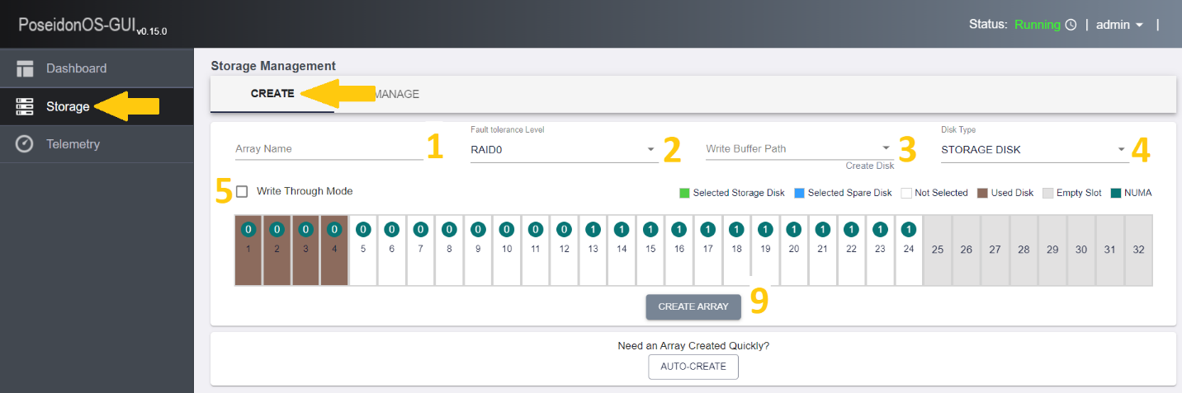

1. *Poseidonos-GUI Array Management*

Follow the steps below to create sample array creation process:

1. Selected storage disk is shown in green
2. Select spare disk is shown in blue
3. Additional details of the disk can be seen when hovering on the colored bar
4. Click on the “Create Array” to create an array  
   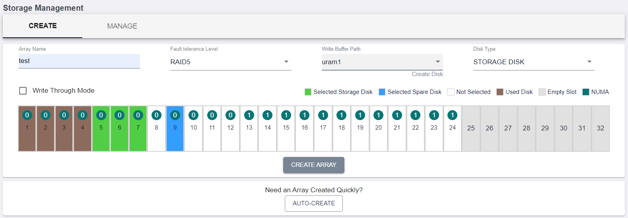
5. *Poseidonos-GUI Array creation steps*

A confirmation message, “**Array Created Successfully**” displayed.

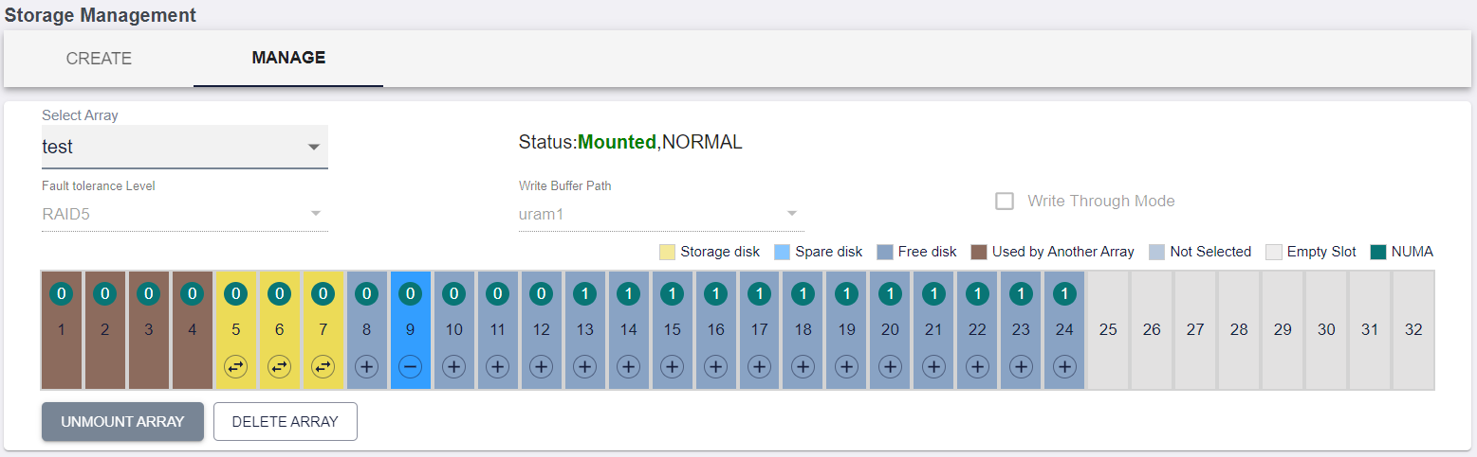

1. *Poseidonos-GUI shows array details after successful array creation*

*Manage Array*

After successful array creation, user has the option to either **delete** or **unmount** an array through the manage section.

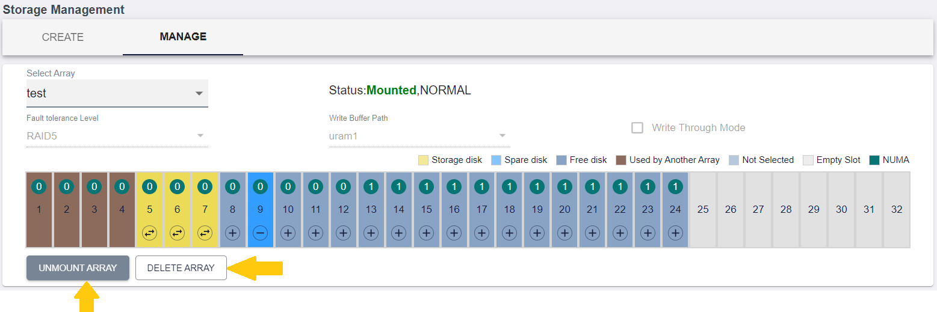

1. *Poseidonos-GUI successful array creation and ability to unmount and delete*
   * + 1. *Unmount Array*

Follow the steps below to unmount array:

1. Click “**Unmount Array**” button
2. By hovering over the “**Unmount Array**” button, the additional info is displayed

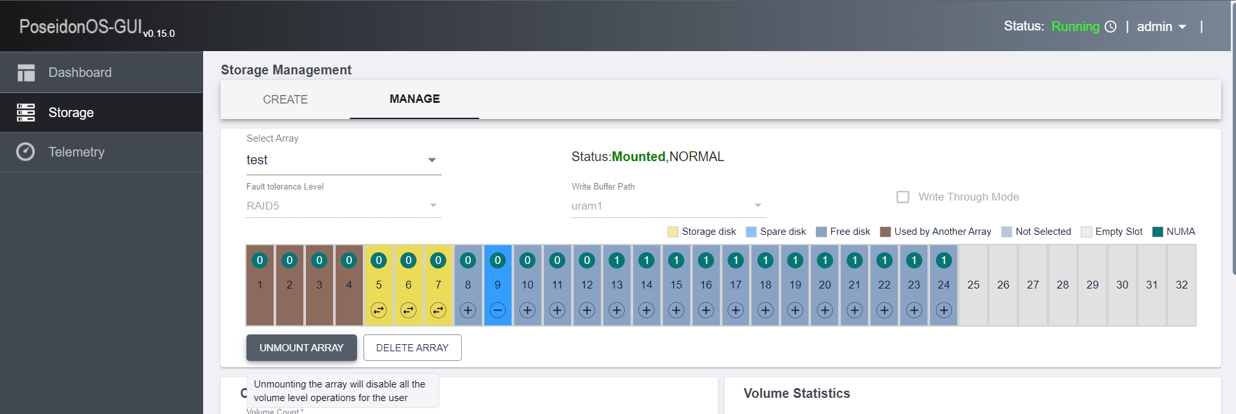

1. *Poseidonos-GUI unmount array operation*

A confirmation message, “**Array Unmounted Successfully**” displayed. 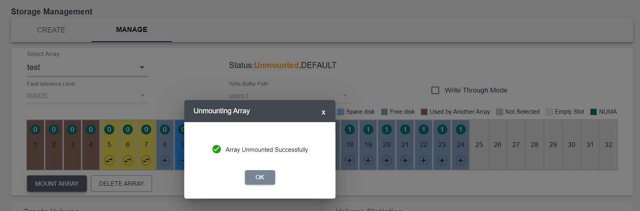

1. *Poseidonos-GUI successful array unmount confirmation* 
   * + 1. *Delete Array*

Follow the steps below to delete array:

1. Click **Delete Array** button
2. A confirmation message is displayed, click **Yes** button to confirm the delete operation

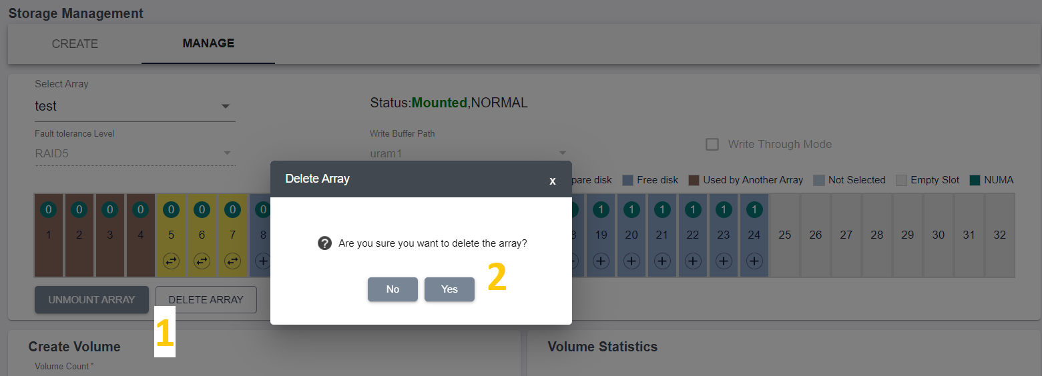

1. *Poseidonos-GUI array deletion confirmation*

A confirmation message, “**Array Deleted Successfully**” displayed.

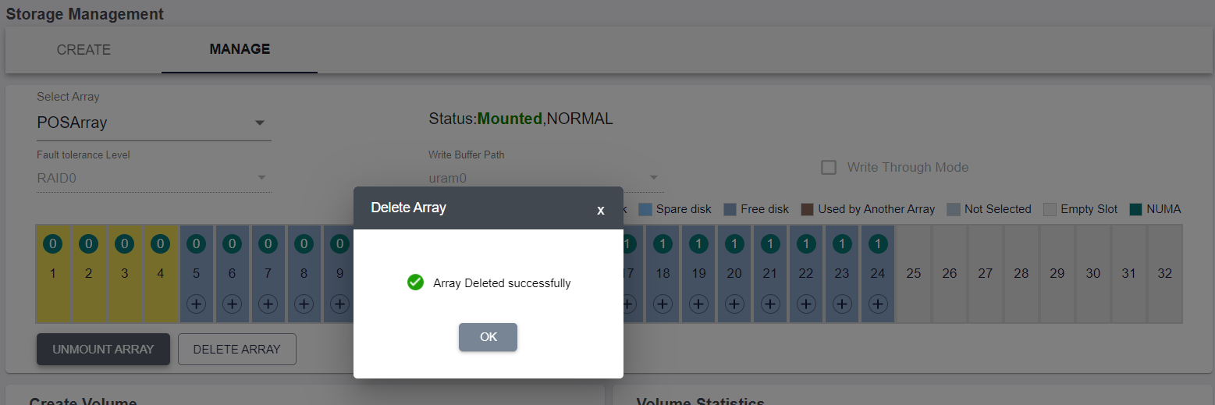

1. *Poseidonos-GUI successful array deletion confirmation*
   * + 1. *Mount Array*

Follow the steps below to unmount array:

1. Select or Unselect the “**Write Through Mode”**
2. Click **“Mount Array**” button
3. By hovering over the “**Mount Array**” button, the additional info is displayed

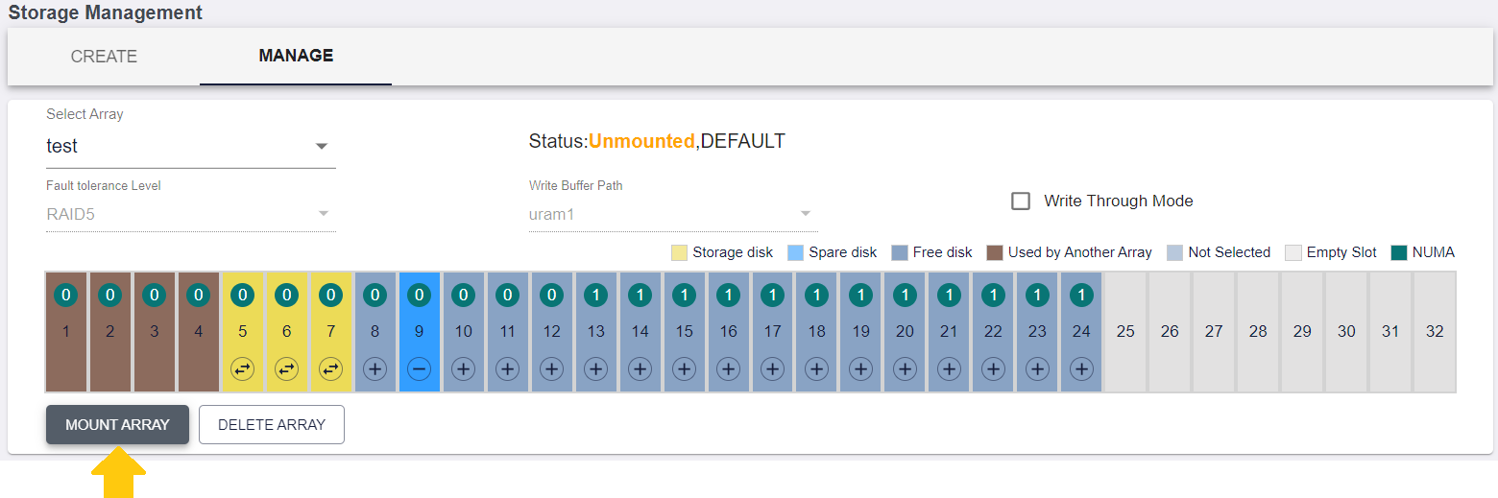

1. Mount Array
   * + 1. *Add Spare Device*

User can add a Spare Device to the array from the list of free devices by clicking on the “+” button on the free device

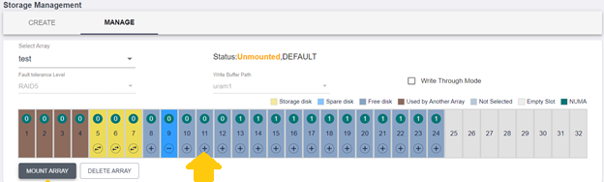

1. Add Spare device
   * + 1. *Remove Spare Device*

User can remove a spare device from the array by clicking on the “-” button on the spare device

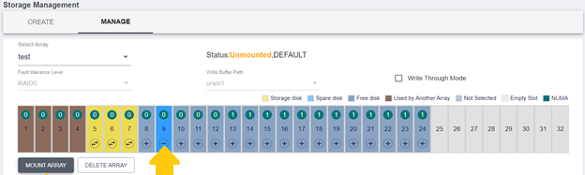

1. Remove Spare device
   * + 1. *Replace Array Device*

User can replace an array device with a spare device by clicking on the “” button on the data device

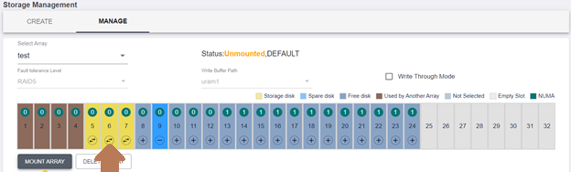

1. Replace Array Device

#### Rebuild Array

When the array is in degraded state, the user can click on the Rebuild Array button to rebuild the array.

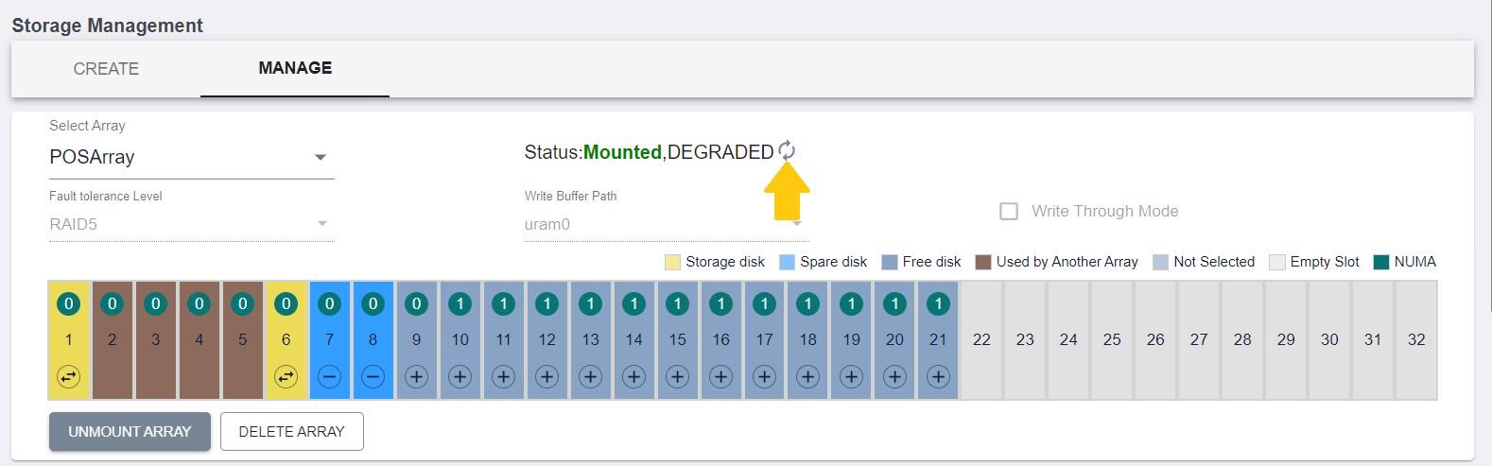

1. Rebuild Array

User can click on the info icon to see the rebuilding progress.

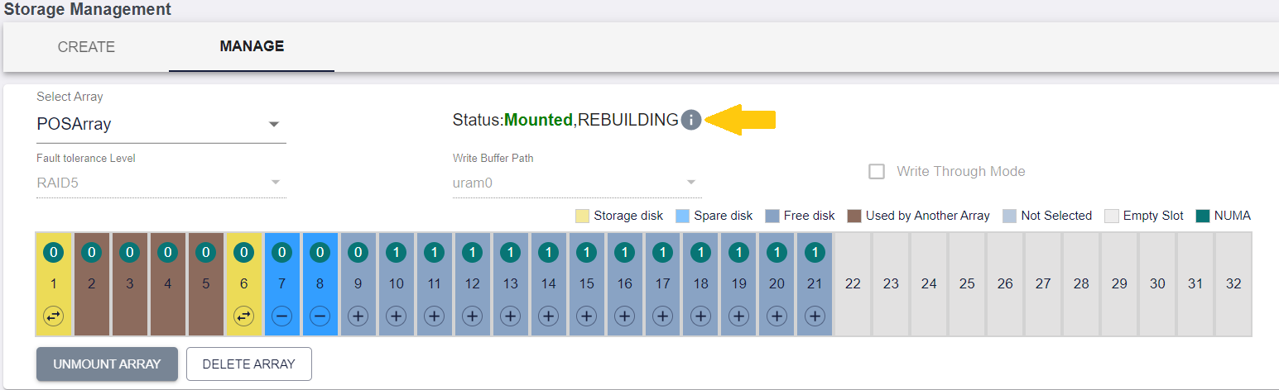

1. Rebuilding status Icon

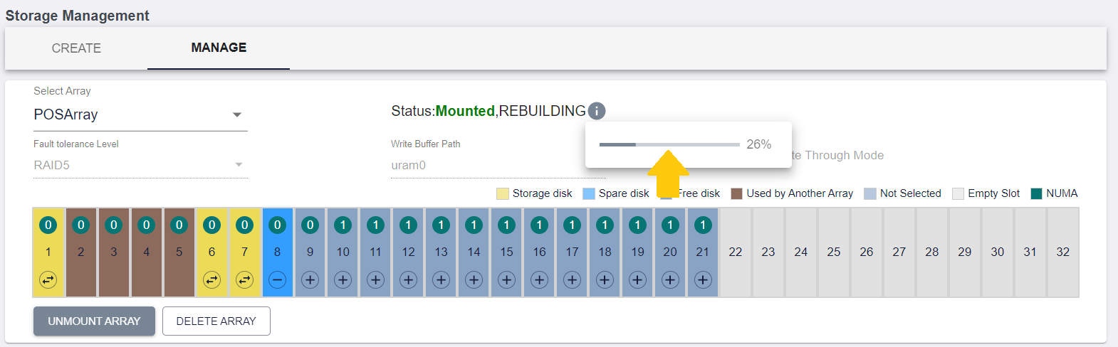

1. Rebuilding Progress
   * 1. ***Volume Management***

Volume management option allows user to create and manage one volume or multiple volumes.

* + - 1. *Create Volume*

Follow the steps below to Manage Volume:

1. User can choose to create one volume or multiple volume. User can enter the number of volume he or she wishes to create.
2. User can enter the volume name (max length of the name is 255). When user tries to create multiple volumes, then user can enter the suffix value to append to the multiple volumes that need to be created.
3. User can choose a number suffix value. For example, if user chooses to create 5 volumes with a volume name as “*volume_company*” and numeric suffix value of 0, then volumes with the following names would be created.
   * Volume_company0
   * Volume_company1 and so on to …
   * volume_company4
4. User can choose to mount the volume or leave it unmounted.
5. User can choose a subsystem in case user wants to mount the volume
6. User can stop the volume creation process when an error occurs.

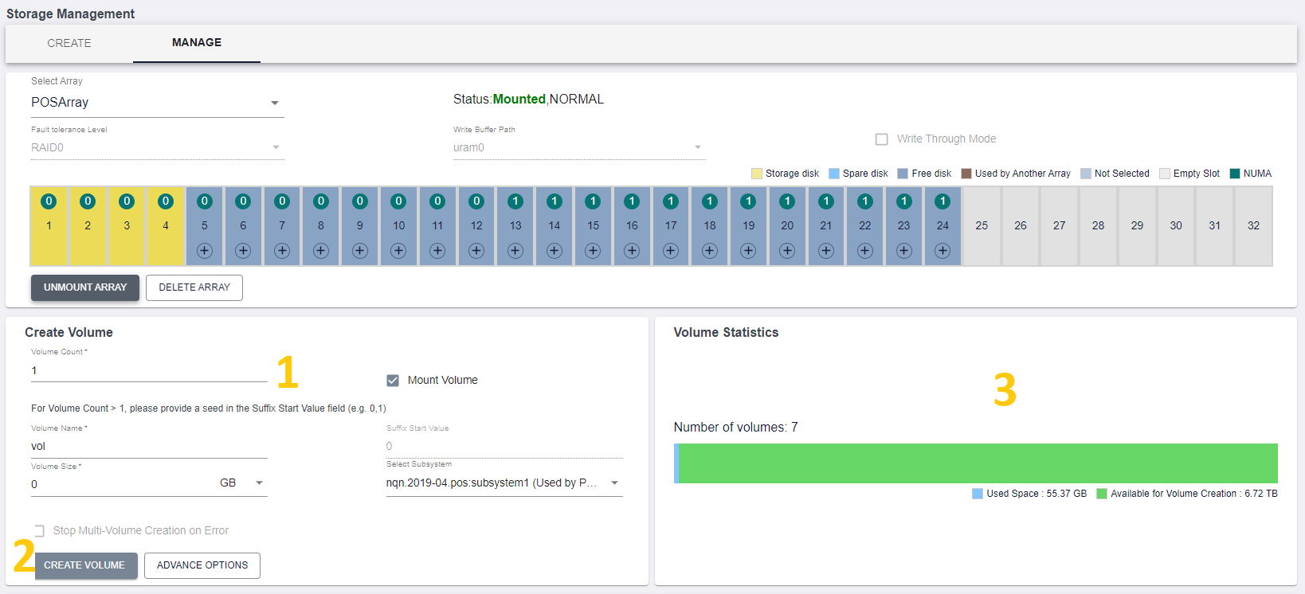

1. *Poseidonos-GUI create volume from Array Manage Page*

Below is a screen showing the volume creation step for 5 volumes.

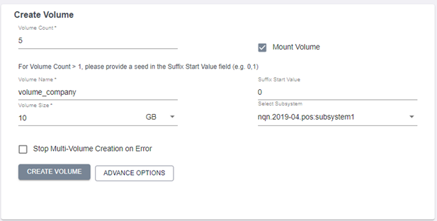

1. *Poseidonos-GUI sample volume create steps*

A user can hit the “CREATE VOLUME” button for Poseidonos-GUI to create the required volumes. Poseidonos-GUI may take a few seconds depending on how many volumes are selected for creation.

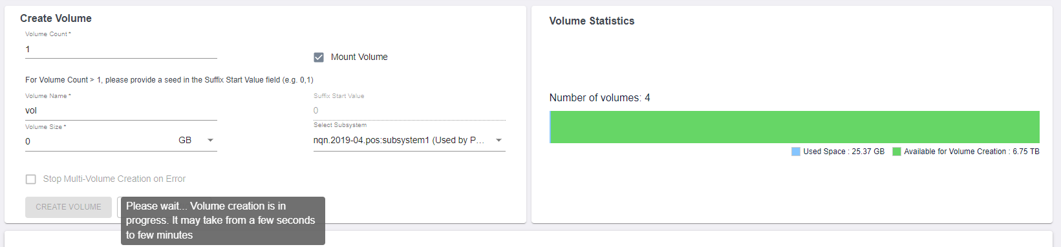

1. *Poseidonos-GUI volume creation intermediate step waiting for processing*
   * + 1. *Advanced Create Volume*

User can select to create a volume with Advance settings using the Advance Options button in the UI.

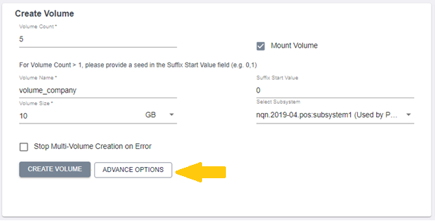

1. *Poseidonos-GUI volume creation with Advance Options*

On clicking the Advance options button, a Popup appears with different sections to enter the details of Volume to be created.

In the first section, user should fill the Volume details. All the fields in this section are similar to the fields described in section 2.3.1.1.

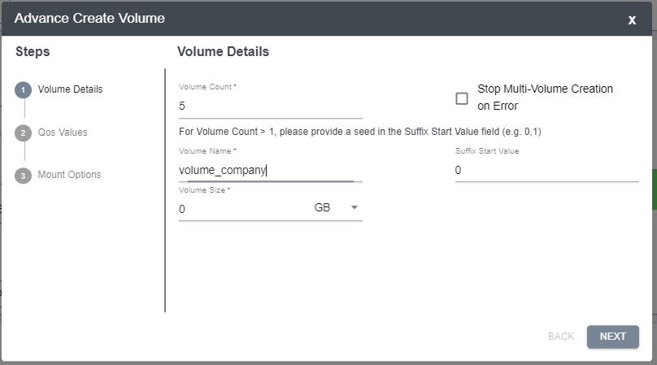

1. *Poseidonos-GUI Advance volume creation – Volume Details*

User should click on the Next button to move to step 2 to fill the details related to QoS values.

In Step 2, user can enter the following Details:

1. Maximum IOPS – The value can be set to 0 to use the maximum value. The minimum value should be 10
2. Maximum Bandwidth – The value can be set to 0 to use the maximum value. The minimum value should be 10
3. Minimum IOPS/BW – The value can be set to 0 to use the minimum value. User can select either to set Minimum IOPS or Minimum Bandwidth

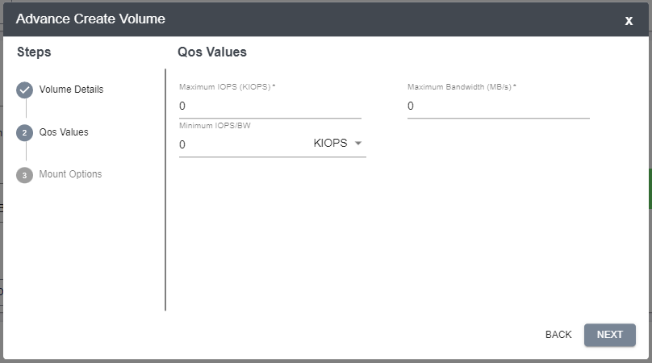

1. *Poseidonos-GUI Advance volume creation – QoS Values*

User should click on the Next button to move to step 2 to fill the details related to Mount Options.

1. The user can select to mount the Volume or to not mount the volume by checking/unchecking the “**Mount Volume”** checkbox.
2. If the user selects the **“Mount Volume”** option, the user can further choose to check/uncheck the **“With a New Subsystem”** checkbox
3. If the user unchecks the **“With a New Subsystem”** checkbox, the user should select an existing subsystem to mount the volume
4. If the user unchecks the **“With a New Subsystem”** checkbox, the user should enter the following details of the new subsystem
   1. **Subsystem Name** – Name of the new subsystem
   2. **Transport Type** – Transport type of the new subsystem
   3. **Target Address** – IP of a listener to the subsystem
   4. **Transport Service ID** – The port through which the listener of the system communicates

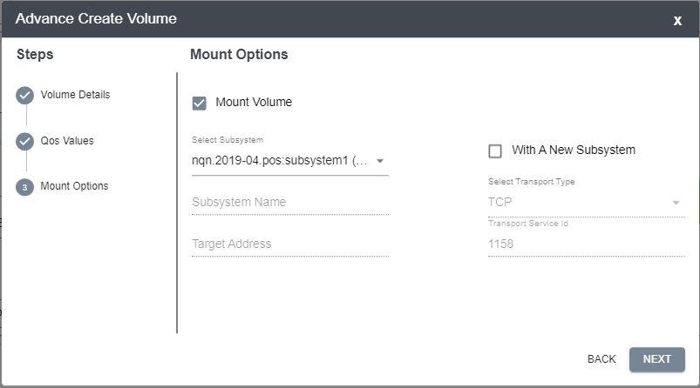

1. *Poseidonos-GUI Advance volume creation – Mount Volume with existing subsystem*

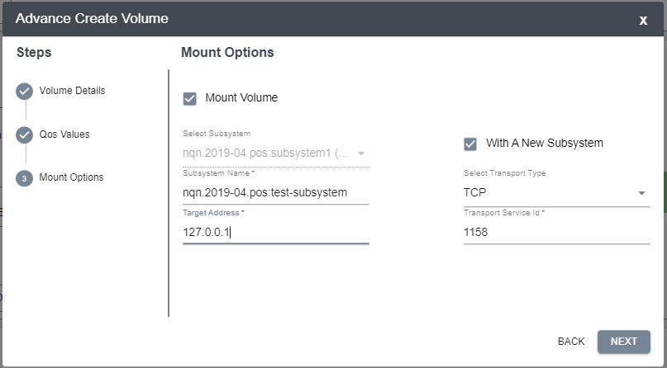

1. *Poseidonos-GUI Advance volume creation – Mount Volume with new subsystem*

The user clicks next after the Mount options are entered. A preview of the etered information is shown.

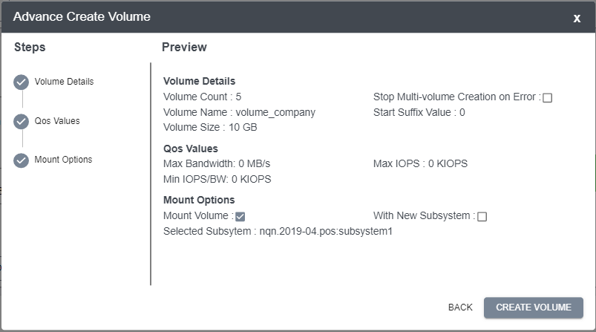

1. *Poseidonos-GUI Advance volume creation – Mount Volume with new subsystem*

If the values look fine, the user should click on the **“CREATE VOLUME”** button for creating the Volume.

On successful creations of volumes, a popup shows that the Volume Creation is successful.

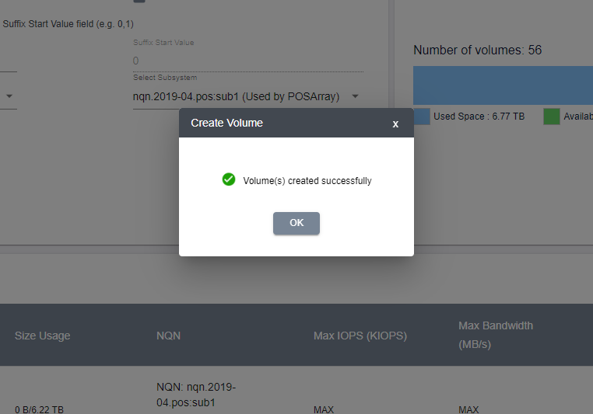

1. *Poseidonos-GUI Advance volume creation – Volume Creation Success popup*
   * + 1. *List Volumes*

Below is a screen showing the volume information for the newly created volumes.

1. User can search for specific volumes by using search terms for size, name, etc.
2. User can select all volumes to delete them.

*Note: Multi volume edit is not supported at this time.*

1. User can select a specific volume to either delete it or edit it.
2. User has option to either mount or unmount the volume by toggling the button.
3. User can select edit option for a specific volume
4. User can reset the QoS Values of a Volume by clicking on the Reset QoS button
5. User can view the total number of volumes in the system

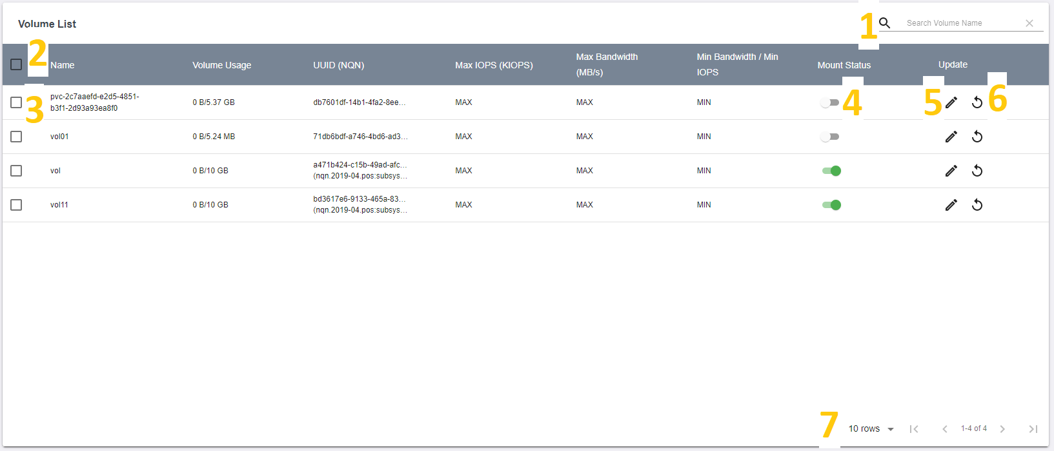

1. *Poseidonos-GUI volume information*

Below is a screen showing *search function* for volume data.

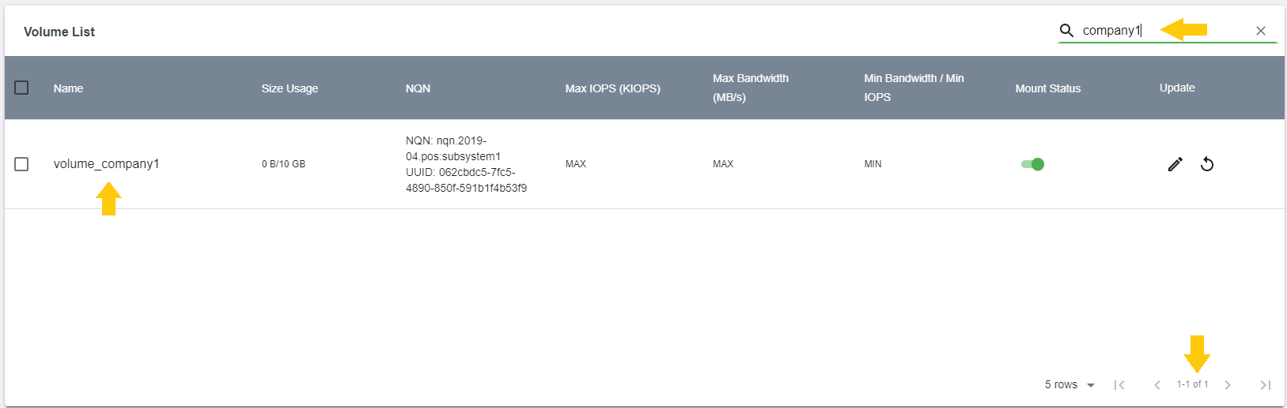

1. *Poseidonos-GUI search volume information by keywords*

Below is a screen showing delete function for all volumes.

1. User can select the checkbox to select all volumes
2. User can click on the delete icon to perform delete operation on all volumes

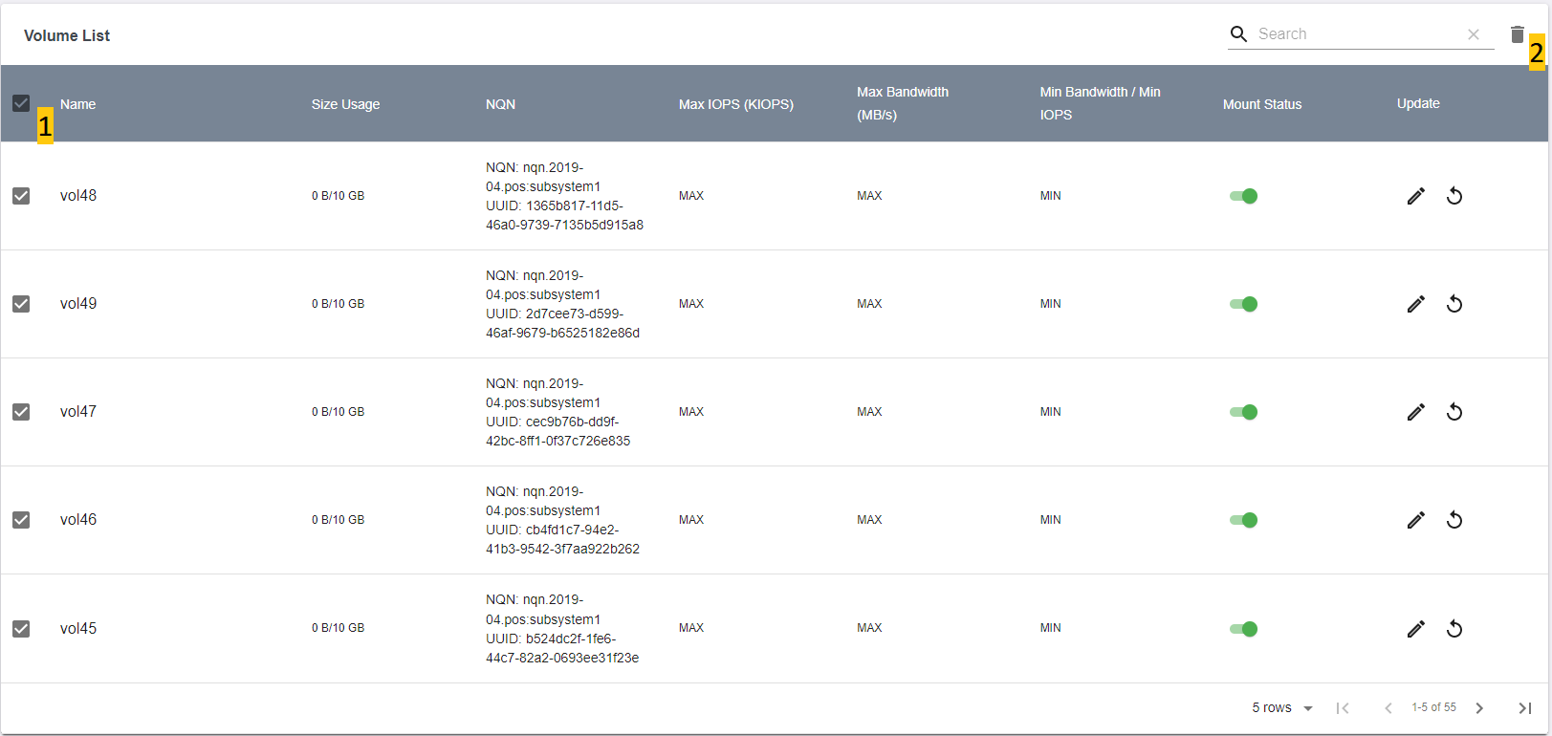

1. *Poseidonos-GUI delete all volumes*

Below is a screen that shows delete function for one or many volumes.

1. User is notified whether one, many or all volumes are selected
2. User can select the checkbox to select one or many volumes
3. User can click on the delete icon to perform delete operation on the selected volumes

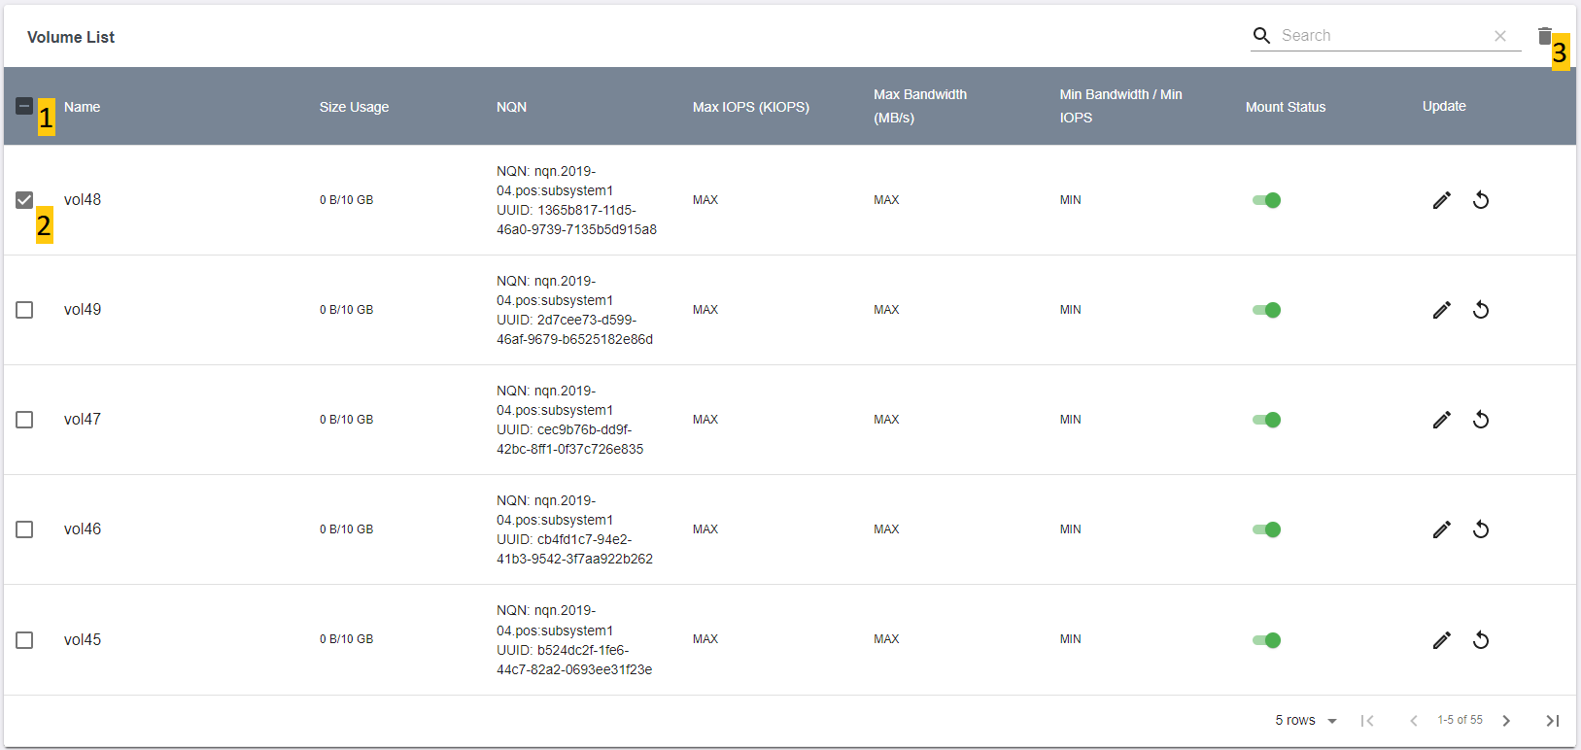

1. *Poseidonos-GUI delete one or more volumes*

The screen below shows confirmation of the unmount operation.

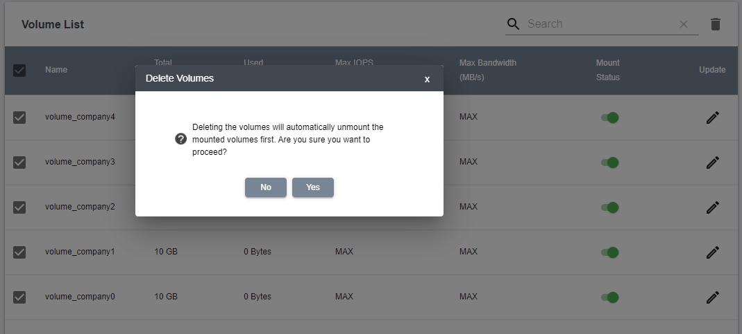

1. *Poseidonos-GUI unmount volume confirmation*

The screen below shows unmount or mount operation on a given volume.

1. User is notified whether volume is mounted or unmounted
2. User can view the mount status of the volume

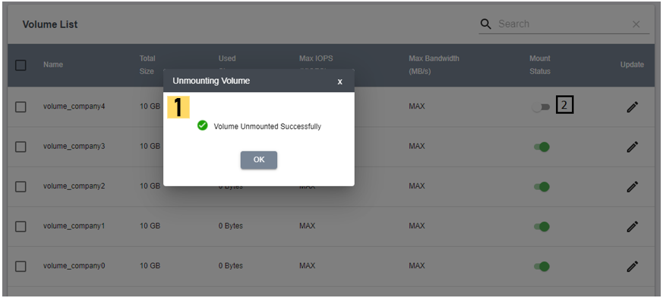

1. *Poseidonos-GUI successful unmount operation confirmation*

The screen below shows update function for a given volume.

1. User can update the name of the volume
2. User can update the IOPS value
3. User can update the bandwidth value
4. User can update the min bandwidth/iops value
5. User can click on the “OK” or “Cancel” button to update or cancel the changes

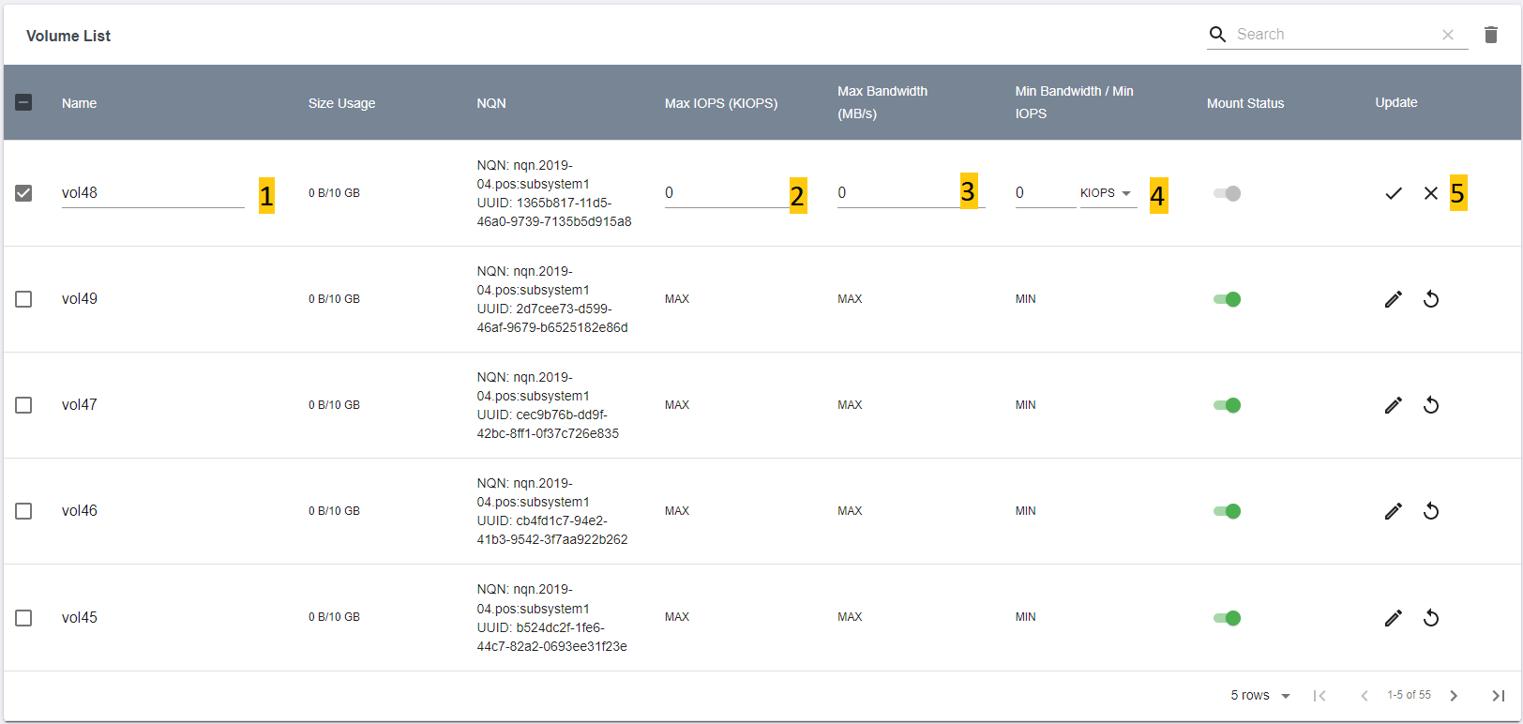

1. *Poseidonos-GUI update volume information*

Screen below shows update operation on a given volume.

1. User is notified whether volume is updated successfully
2. User can view the updated data of the volume

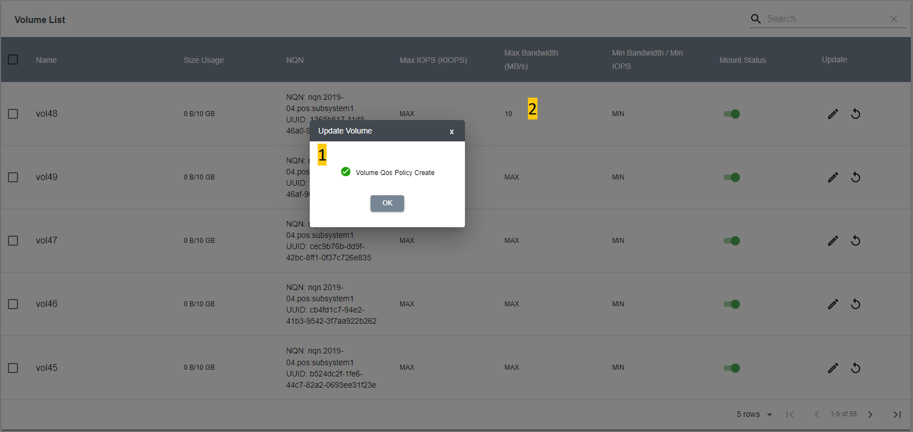

1. *Poseidonos-GUI update volume information confirmation*
   1. **Poseidonos-GUI Telemetry**

The Telemetry page allows user to configure telemetry and view the embedded Grafana UI.

* + 1. ***Telemetry Configure***

The Telemetry configure page allows the following operations:

1. User can start the Telemetry
2. User can stop the Telemetry
3. User can see the status of Telemetry
4. User can select/unselect all properties of telemetry
5. User can select/unselect all properties in a group in telemetry
6. User can select/unselect a single property in telemetry
7. User can Save the selected properties

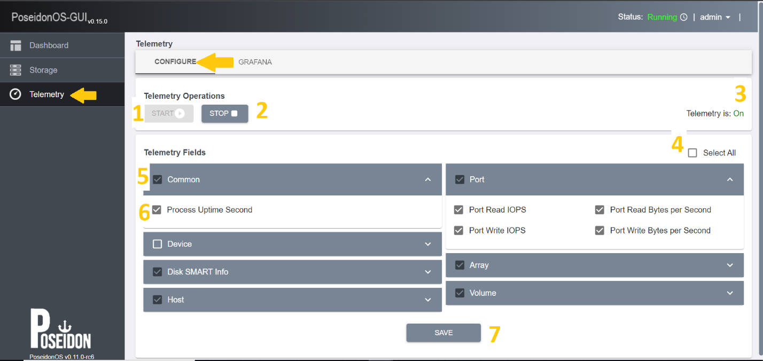

1. Telemetry COnfiguration
   * 1. ***Grafana***

Users can view the Grafana UI embedded inside the PoseidonOS-GUI by navigating to the Grafana tab.

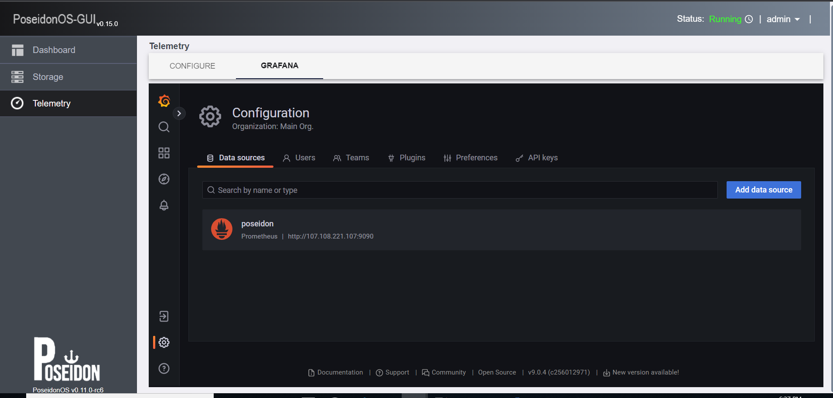

1. Grafana UI
   1. **Poseidonos-GUI User Management**

The user management page allows admins to add a new user and modify Username, Email Id, Mobile Number fields of an existing user.

* + - 1. *New User*

User Addition requires six fields i.e. Username, Role, Password, Confirm password, Mobile Number and Email ID.

Follow the steps below to add a new user:

1. User can add a new user by providing
   * User name
   * Password
   * Phone
2. User can choose the default role “Admin”
3. User can save changes by clicking on “**Submit**” button

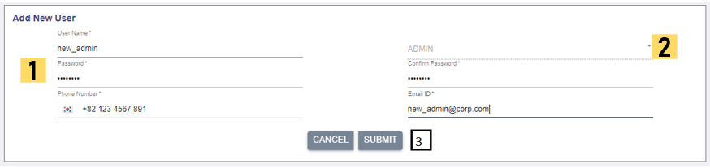

1. *Poseidonos-GUI add new user information*
   * + 1. *Delete User*

User Deletion allows the admins to delete the entire user(s) details.

*Note: If a user record is deleted by the admin, the user would not be able to login to the management portal.*

1. Admins can view or update existing users and their information.
2. Admins can use **Add New User** functionality to re-add the user.

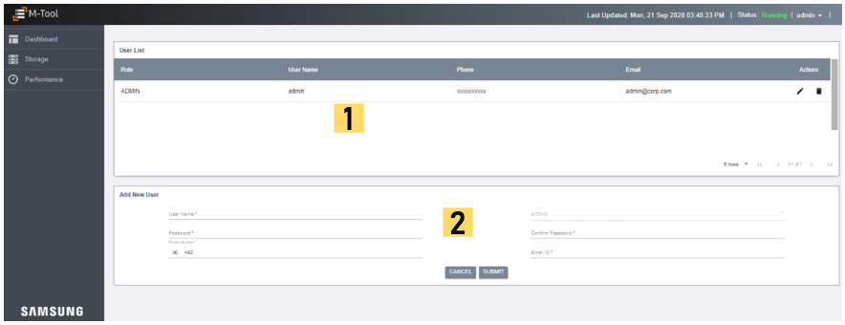

1. *Poseidonos-GUI user management page*
   * + 1. *Modify User*

User Modification allows the admins to modify Username, Active Status, Email Id, Mobile Number fields of an existing user.

*Note: If a user's active status is disabled by the admin, then the user would not be able to login till the status is reverted to active state by the admin*

Follow the steps below to update a given user information:

1. User can update the phone
2. User can update an email
3. User can either save changes or discard them

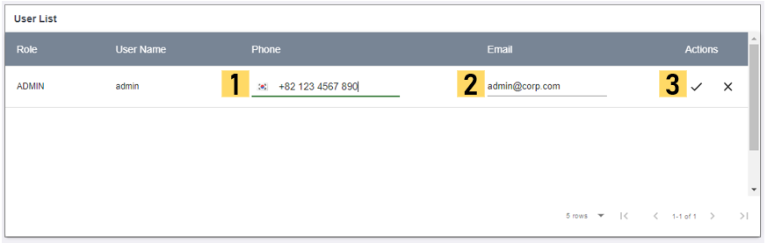

1. *Poseidonos-GUI update user information*
   1. **Poseidonos-GUI Storage Management Operations and Configurations**

This page allows users to do operations like Start or Stop Poseidonos, set and get rebuild property, device operations and subsystem related operations.

The Poseidonos operations page has three tabs:

1. Operations
2. Devices
3. Subsystem

The user can navigate to the operations page by clicking on the **“Poseidon Operations”** link in the dropdown in the header

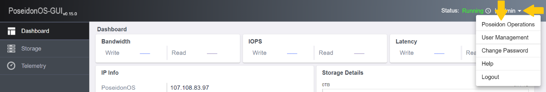

1. *Poseidonos-GUI POS Operations Navigation*
   * 1. ***Poseidonos Operations***

The operations page allows the user to do the following operations:

1. Start Poseidonos
2. Stop Poseidonos
3. Display the status of Poseidonos
4. The performance impact during Rebuild can be selected
5. The Selected level of Impact can be set using the button “SET PROPERTY”
6. The current impact level is displayed

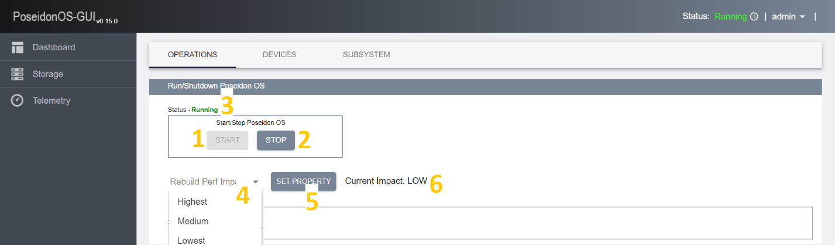

1. *Poseidonos-GUI POS Operations*
   * 1. ***Devices***

The Devices page allows users to create and list the buffer devices.

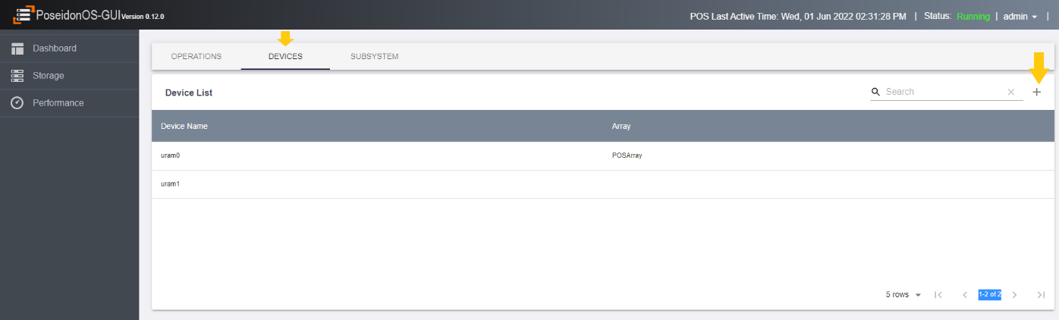

1. *Poseidonos-GUI Devices*

To create a buffer device, user should click on the **“+”** button.

On clicking the **“+”** button, a popup appears for creating a buffer device. The following fields should be filled for creating the device.

1. Disk Name
2. Block Size
3. Number of Blocks
4. NUMA
5. Disk Type

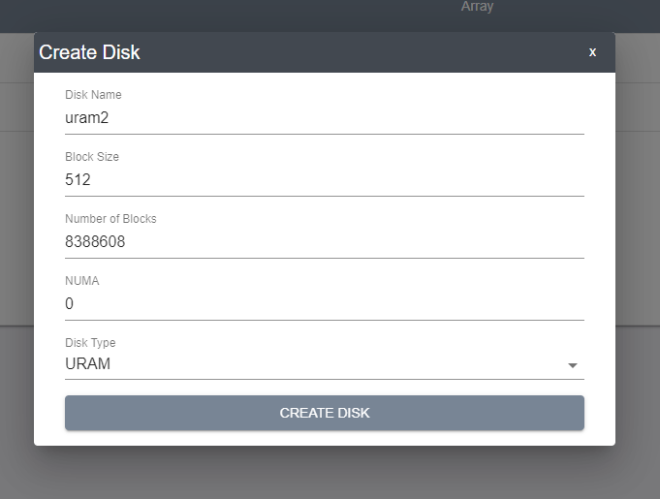

1. *Poseidonos-GUI Create Disk*
   * 1. ***Subsystems***

The Subsystems page allows users to create and list the subsystems.

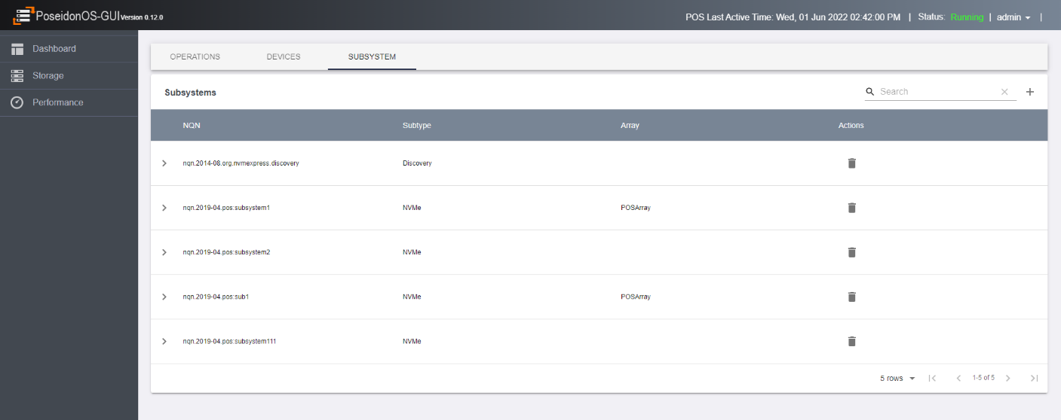

1. *Poseidonos-GUI Subsystem list*

To create a new subsystem, the **“+”** button can be clicked. A new popup will appear for entering details of new subsystem

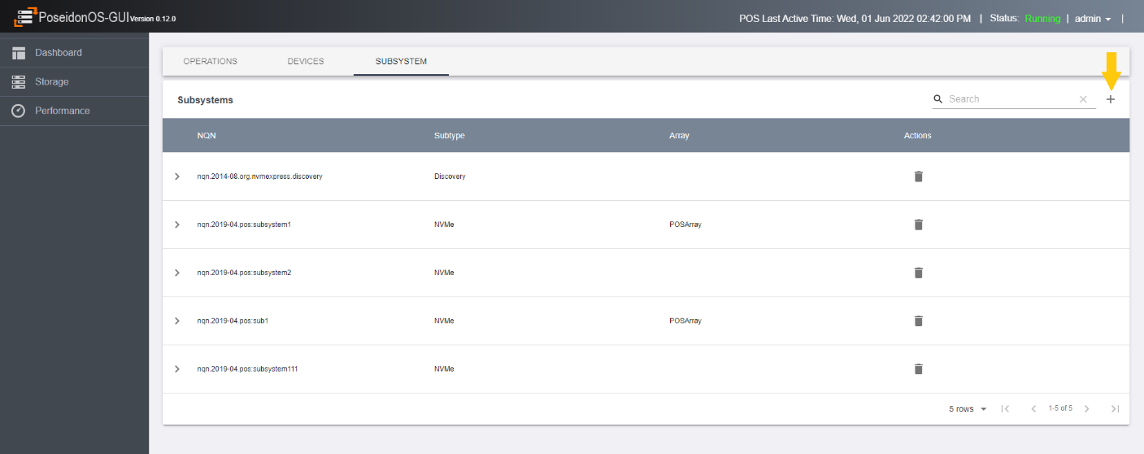

1. *Poseidonos-GUI Create Subsystem*

The user should enter the following details for creating the subsystem:

1. SubNQN name
2. Serial Number
3. Model Number
4. Maximum Namespaces
5. Allow Any Hosts

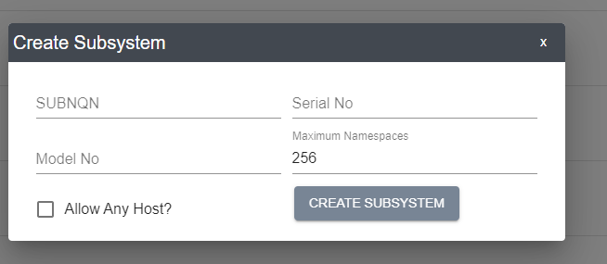

1. *Poseidonos-GUI Create Subsystem Popup*

User can click on the delete button to delete a subsystem

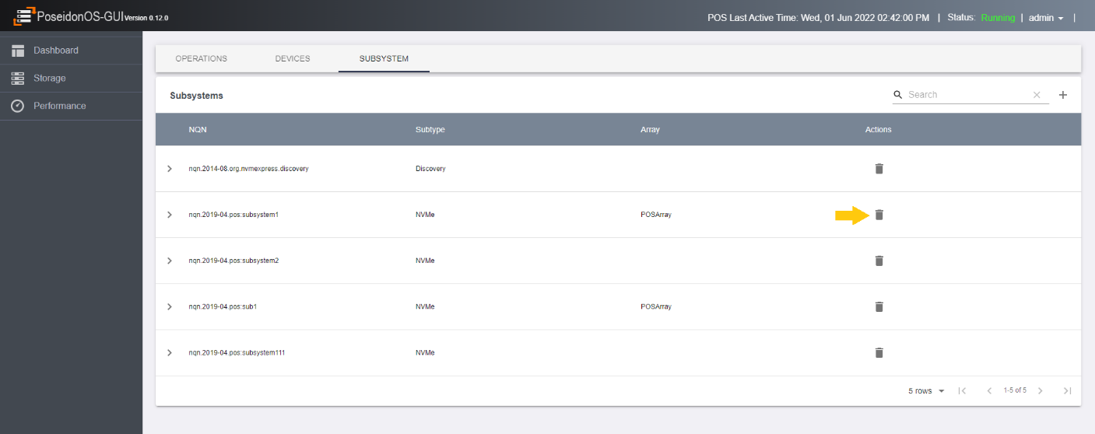

1. *Poseidonos-GUI Delete Subsystem*

User can get the details of a subsystem by clicking on the **“>”** button

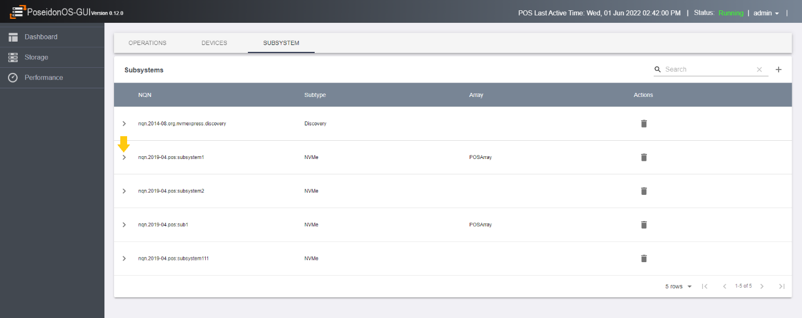

1. *Poseidonos-GUI Subsystem Expand*

The following details will be available:

1. SubNQN name
2. Serial Number
3. Model Number
4. Maximum Namespaces
5. Allow Any Hosts
6. List of Namespaces
7. Listen Addresses

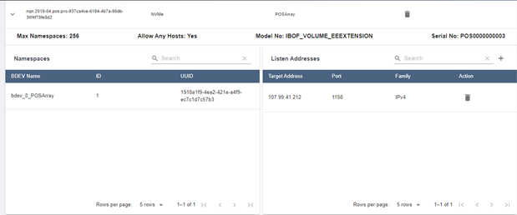

1. *Poseidonos-GUI Subsystem Details*

The user can create listen address by clicking on the **“+”** button on the Listen Addresses table.

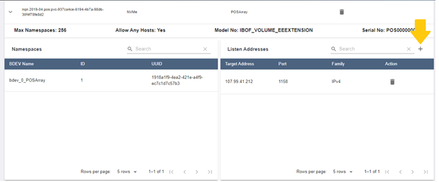

1. *Poseidonos-GUI Add Listener*

The user should enter the following details to add a listener to a subsystem:

1. IP
2. Port
3. Transport type

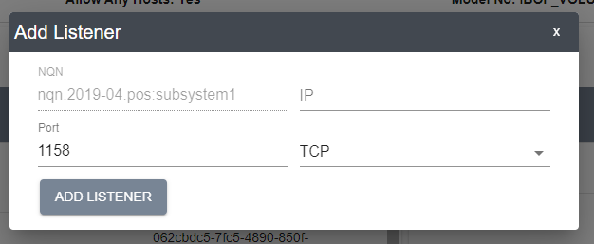

1. *Poseidonos-GUI Add Listener Popup*

On clicking the **“Add Listener”** the listener should be added to the subsystem. A popup with the success message should be displayed

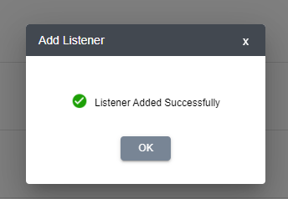

1. *Poseidonos-GUI Add Listener Success*

The user cans delete a listener by clicking on the Trash icon near the corresponding listener.

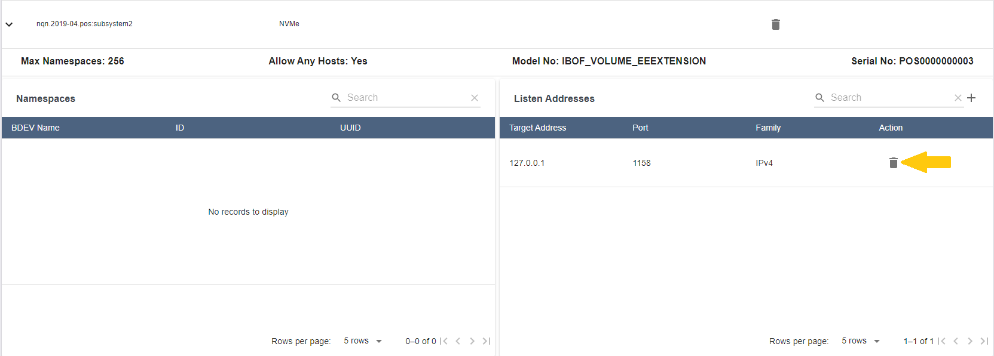

1. Delete Listener

### Transport

The Transports page allows users to create and list the transport.

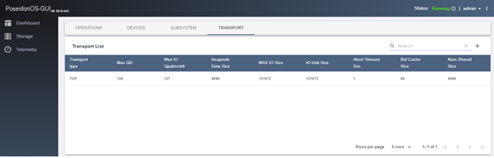

1. PoseidonOS-GUI Transport List

To create a new transport, the “+” button can be clicked. A new popup will appear for entering details of new transport

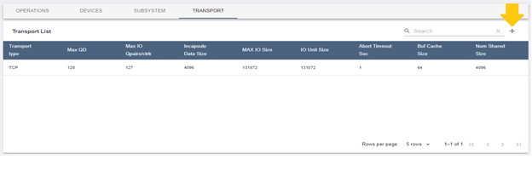

1. PoseidonOS-GUI Create Transport

The user should enter the following details for creating the transport:

1. Transport Type

2. Buf Cache Size

3. Num Shared Buf

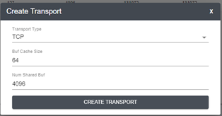

1. PoseidonOS-GUI Create Transport Popup
2. **How to install Poseidonos-GUI**

Follow the steps below to set up and run the Poseidonos-GUI (the scripts shown below are available in the root directory)

**Prerequisites**

1. python3

2. go v1.14+

3. nodejs 14.x

4. InfluxDB (1.8.x)

**Supported OS and Version**

1. Linux Ubuntu 18.04

**Download and Install dependencies**

1. Clone the project from GitHub - <https://github.com/poseidonos/poseidonos-gui.git>

2. Navigate to poseidonos-gui directory

3. Run scripts as described below to install and run the application

4. Access the application in the browser (e.g. http://<local_ip_addr>)

1. git clone https://github.com/poseidonos/poseidonos-gui.git

2. cd poseidonos-gui

3. ./script/install_all.sh

4. ./script/build_all.sh

5. ./script/run_all.sh

*1. Install Packages*

These packages are required for proper working of the Poseidonos-GUI. This will install required packages such as influxdb, chronograf, kapacitor on the host.

*./script/install_all.sh*

*2. Build the application*

*./script/build_all.sh*

*3. Run application*

To run various applications, use this command below.

*./script/run_all.sh*

*3. Access the Poseidonos-GUI application via browser*

The server will run on the local web server and will be accessible from the browser

*http://<ip_address>*

1. **How to Uninstall Poseidonos-GUI**

Follow the steps below to uninstall the Poseidonos-GUI (the scripts shown below are available in the root directory)

*1. Uninstall services and applications running*

*./script/uninstall.sh*